Salads and Light fare

Cup of Homemade Soup $4.50
Ask your server for today’s soup

Half Sandwich Combo $ 7.25
Choice of our slow smoked turkey breast, thin sliced ham, chicken salad or tuna salad with lettuce and tomato on your choice of toasted bread. Served with fresh fruit salad or a cup of soup
Add cheese $1.00
Add bacon $2.50

Half Salad and Soup $7.25
Half sized of any our salad choices served with a cup of homemade soup

Chicken Fingers $8.75
Fried chicken fingers served with French fries or tots

Grilled Hot Dog $6.25
Quarter pound hot dog grilled to perfection. Served on a toasted bun with chips

Doo Dah Dog $8.75
Our quarter pound hotdog wrapped with American cheese and bacon

Summer Salad $11.25
Spring mix topped with cherry tomatoes, Jersey blueberries, fresh strawberries, crumbled goat cheese, and candied walnuts served with a homemade pomegranate vinaigrette dressing
Add Grilled Chicken +$3.00

Spinach Salad $11.25
Bed of baby spinach, hardboiled egg, sliced granny smith apples, and dried cranberries served with a homemade pomegranate vinaigrette dressing

Strawberry Caprese Salad $11.25
Baby spinach, basil & greens tossed with
strawberries, fresh mozzarella, and candied walnuts topped with a balsamic Reduction
Add Grilled Chicken +$3.00
Add Chicken Salad +$3.00
Add Crab Cake +$6.00

Italian Chicken Salad $11.75
Our hand breaded chicken breast deep fried and sliced served on a bed of greens with fresh mozzarella and roasted red peppers

Buffalo Shrimp Salad $12.75
Our jumbo breaded fried shrimp tossed in a homemade buffalo sauce served on a bed of greens, cherry tomatoes, carrots, & goat cheese
Cold Sandwiches
served with potato chips
choice of bread, toast or Honey wheat wrap

Homemade Chicken Salad $8.75
Cranberries, pecans, & chicken breast tossed with mayo, onion, celery and grapes. Served with lettuce and tomato

BLT $7.75
Fresh hot bacon, cold crisp lettuce and thick sliced tomato piled high

Tuna or Egg salad sandwich $8.75
Choice of tuna salad, or Egg Salad served with lettuce and tomato

Caprese Sandwich $8.75
Fresh mozzarella, thick sliced tomato, Garden fresh basil and balsamic reduction served on our homemade round roll

Hot Sandwiches
served with Fries or Tots
Served on a Homemade Round Roll

Pulled Pork Sandwich $9.75
slow smoked pulled pork, cheddar cheese, coleslaw and our house BBQ sauce

The Deputy Chief DiMarco $9.75
Our hand breaded chicken breast deep fried and topped with fresh mozzarella, spinach and roasted red pepper. Finished with a balsamic reduction

Grilled Chicken Breast $9.75
topped with roasted red peppers, fresh mozzarella, tomatoes, and fresh basil finished with a balsamic reduction

Chicken Parmesan Sandwich $8.75
Our hand breaded chicken breast deep fried and topped with house marinara and fresh mozzarella

Buffalo Chicken Sandwich $8.75
Hand breaded chicken breast deep fried and tossed with our mild or hot buffalo sauce. Served with blue cheese, celery and carrots

Jumbo Lump Crab Cake $10.25
Our homemade jumbo lump crab cake topped with a roasted red pepper pesto

Clay’s High Heat Chicken $8.75
Our breaded chicken breast deep fried and topped with ghost pepper cheese. Served with shredded lettuce and ranch dressing
Burgers
served with fries or tots
Freshly Ground
Served on A Homemade Round Roll

Our Half Pounder $8.75
Our fresh ground half pound burger cooked the way you like
Add choice of cheese $1.00
Add bacon $2.50

Breakfast Burger $10.25
Our fresh ground half pound burger topped with cheddar or American cheese, & a fried egg. Served with tomato and shredded lettuce

BBQ Burger $11.75
Our fresh ground half pound burger topped with bacon, cheddar cheese, onion rings and our house BBQ sauce. Served with tomato and shredded lettuce

Hooked Burger $11.75
Our fresh ground half pound burger topped with cheddar cheese, a fried egg, pork roll & bacon. Served with tomato and shredded lettuce

Mushroom Burger $10.25
Our fresh ground half pound burger topped with cheddar or American cheese, sautéed mushrooms. Served with tomato and shredded lettuce

Pulled Pork Burger $12.75
Our fresh ground half pound burger topped with cheddar cheese, pulled pork, coleslaw & onion rings. Smothered in our homemade bbq sauce. Served with tomato and shredded lettuce

Shore Points burger $13.75
Our fresh ground half pound burger topped with jumbo fried shrimp, sautéed asparagus and smothered in our house old bay mayo. Served with tomato and shredded lettuce

Flying J Burger $13.75
Our fresh ground half pound burger topped with our homemade crab cake & finished with a homemade old bay mayo. Served with tomato and shredded lettuce

Grilled Sandwiches
served with Fries or Tots
Served on grilled Texas toast

Turkey Apple Melt $10.25
Our slow smoked turkey breast topped with sliced granny smith apples & melted brie cheese finished with pomegranate vinaigrette dressing

Grilled Cheese $5.75
American or cheddar cheese
Add any meat $2.50 each
Add any vegetable $.50 each

Loaded Grilled Cheese $8.75
Melted cheddar cheese, slow smoked pulled pork and a touch of our house BBQ sauce

Ultimate Veggie grilled cheese $8.25
Melted cheddar cheese with sautéed spinach, tomato, asparagus, onions, & mushrooms

Greek Grilled Cheese $6.75
Sautéed spinach and tomato with melted feta cheese grilled to perfection

Bacon Apple Cheddar $8.75
Thick bacon, sliced apple and melted cheddar cheese

Buffalo Chicken Grilled Cheese $8.75
All white meat chicken breast chopped and grilled smothered in our house buffalo sauce and melted cheddar cheese

Grilled S’mores Sandwich $7.25
Melted Nutella and marshmallows

Sides

French Fries $2.75
Mozzarella Sticks $5.25
Tater Tots $2.75
Onion Rings $3.75
Corn Fritters $2.75
Applesauce $1.75
Coleslaw $1.75
Potato Chips $2.00

Gift Cards Available

Schedule your own private party – please see a manager for more information

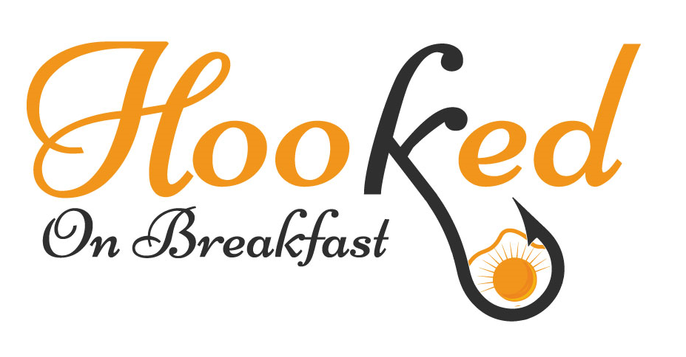

916 Asbury Avenue
Ocean City, NJ 08226
609-938-9285

Visit Us on The Web At
Hookedonbreakfast.com

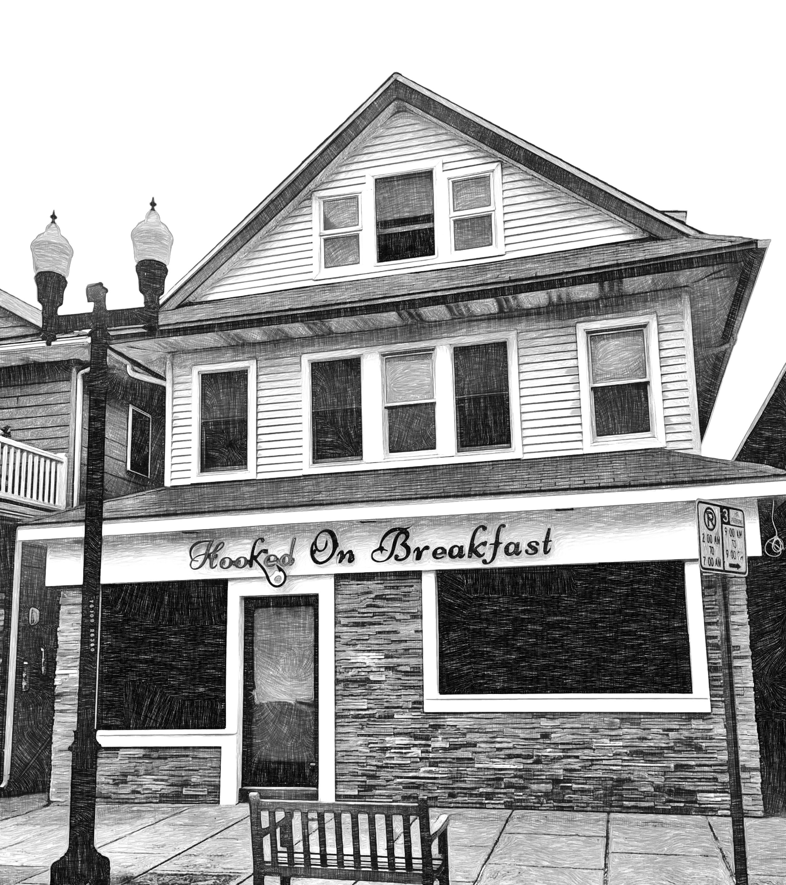

916 Asbury Avenue
Ocean City, NJ 08226
609-938-9285

Visit Us On The Web At
Hookedonbreakfast.com

